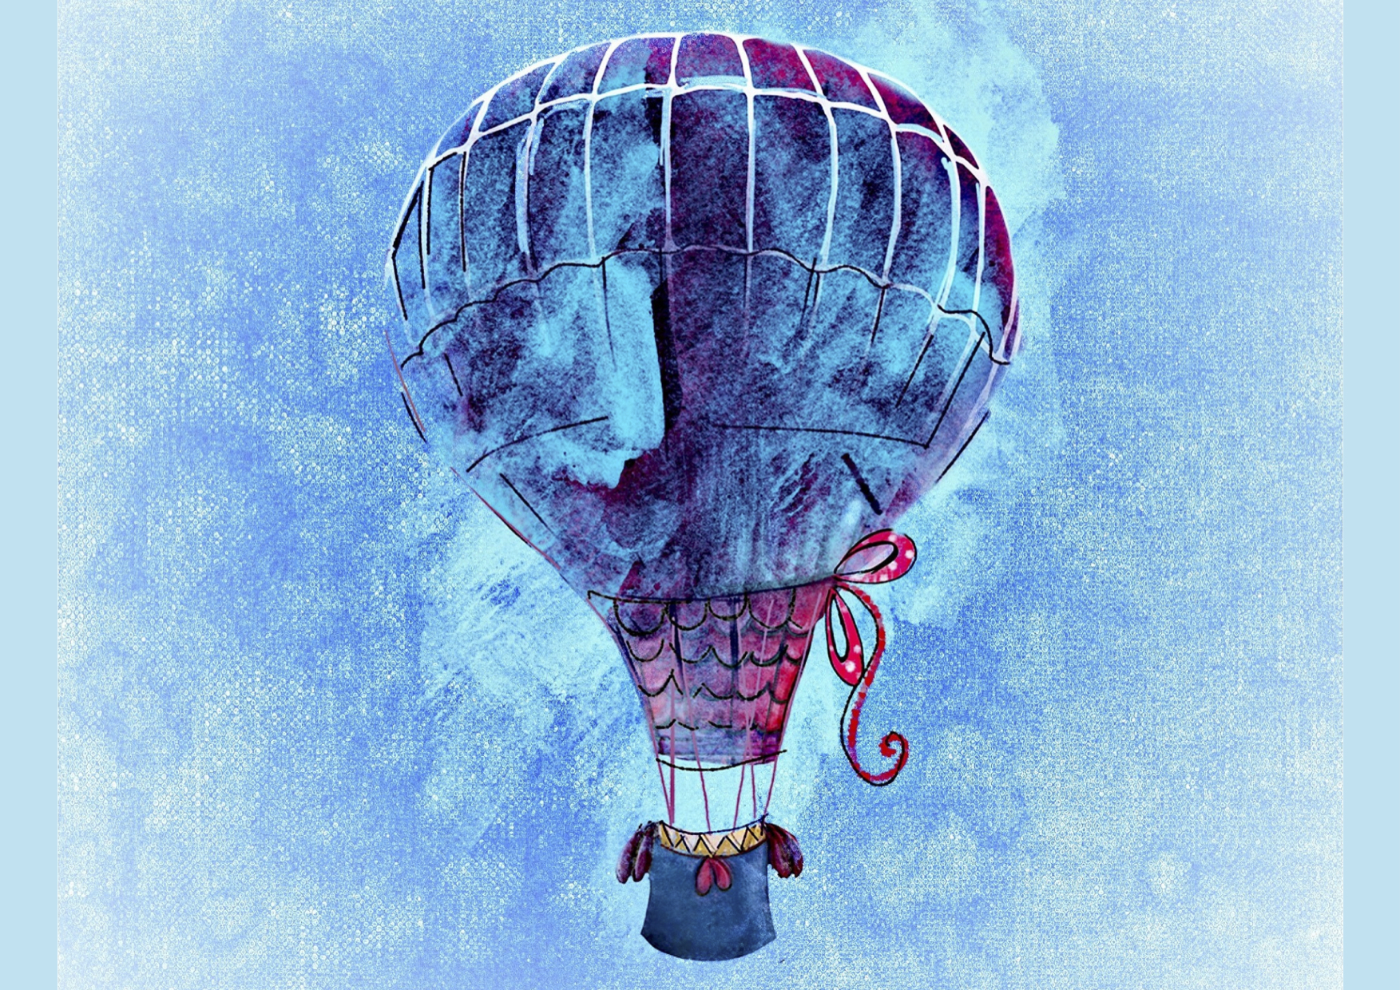
Hot Air Balloon Image to work from

